Communicating Climate Change and Energy Transition in Canada Worksheet

The message triangle highlights key themes to integrate and repeat in communications. Tailor specific messages to the interests, concerns and values of your intended audiences.

When you hit each of the points on the triangle, you remove key barriers to public engagement and create a complete narrative for your audience, giving them a full picture of our climate predicament, the way forward and the benefits of taking action.

You can start at any point — wherever your audience is on the issue or what they care about — then weave in the other two points. Create narrative tension via the challenge (a problem to solve or aspiration to achieve), a pathway or choice that must be made (what can be done) and the opportunities or benefits of making the right choice.

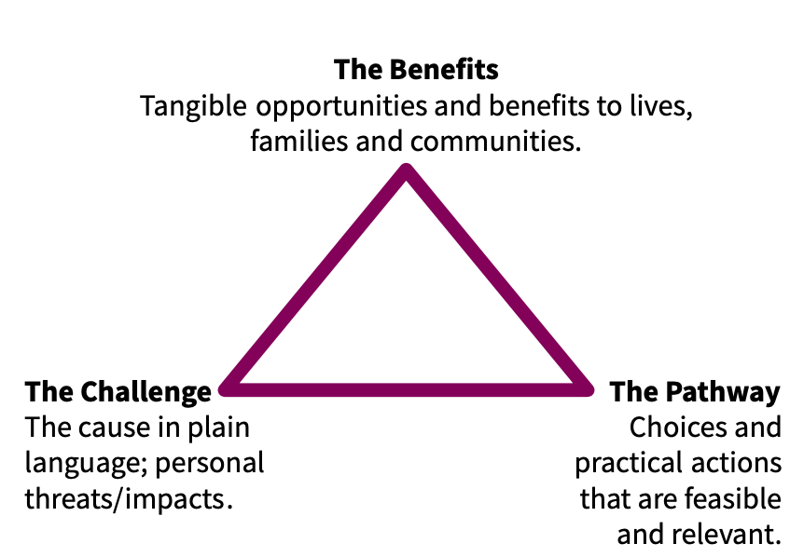

STEP ONE: CHOOSE YOUR AUDIENCE
Begin by understanding the audience(s) you want to engage.
  - What is a key audience in your region?
  - What do they care about?
  - What are key barriers to their engagement (consider identity, literacy, competing priorities, sense of efficacy, lack of relevance)
  - How/where do they get their information?
  - Who do they most trust?

Some examples of audiences include:
  - Alarmed/environmentalists
  - Business owners
  - Educators (K-12) other post-secondary
  - Energy professionals + workers (renewable/oil)
  - Faith leaders
  - First Nations & Indigenous leaders
  - Farmers and ranchers
  - Healthcare + HNGOs
  - Local gov’t: policymakers + planners
  - Moms/parents
  - Tourism & recreation users

STEP TWO: IDENTIFY RELEVANT IMPACTS/THREATS/OPPORTUNITY (THE CHALLENGE)

Part of the challenge is that people view climate change as an environmental issue and do not necessarily connect impacts to health, food, livelihoods or other parts of their daily lives. Talk about the impacts from the perspective of your audience.

Ask This:
- What are key threats/impacts or opportunities your audience cares about? I.e. Poor air quality in your region? Impacts to livelihoods from moving away from oil and gas? Economic opportunities? Affordability? Safety?
- What does your audience stand to gain from an energy transition? What do they stand to lose?

Remember
- Tie the challenge back to the cause -- pollution blanket overheating the earth.

STEP THREE: HIGHLIGHT THE SOLUTIONS (THE PATHWAY)
Inspire new thinking about what’s possible by elevating practical and feasible examples — ideally local — whenever possible.

Ask This:
  - What actions are possible at the local level (think both local government but also civic actions)?
  - What actions are possible at the provincial level?
  - What actions are possible at the federal level?
  - What solution(s) are your organizations offering?

STEP FOUR: EMPHASIZE THE BENEFITS
Hone in on the benefits of climate action most relevant to your audience(s) by talking about what will improve for their lives, families and communities or other things they care about. Make the case for support.

Ask This:
  - What does your audience stand to win? How will their lives, personally, improve?
  - What are the benefits of acting now?
  - How does taking action on this problem/opportunity intersect with other issues people in your community care about?
  - How do the economic benefits tie into values?

